Milestone 4: Narrative Enhancement 3 Databases
Karina Washington
Southern New Hampshire University
CS 499
November 22nd, 2025

Artifact Overview
In this enhancement, I worked with my Travlr Getaways project from CS-465 Full-Stack Development. This application is a full-stack travel management system built with Node.js, Express, MongoDB, and Mongoose, along with Handlebars for server-side views. The original version allowed users to view trips and allowed admins to manage travel packages by interacting with a MongoDB collection. I created the original artifact during my CS-465 course as a final project to demonstrate my understanding of RESTful APIs, MVC architecture, and basic database integration. For the CS-499 capstone, I selected this artifact to enhance the database layer, data validation, API reliability, and security-minded design.
Reason for Inclusion in the ePortfolio
I chose this artifact for my ePortfolio because it is the clearest example of my ability to work with a real database-backed web application rather than just isolated scripts. It already included a travel “Trips” collection, Mongoose schemas, and CRUD routes, which made it a strong foundation for demonstrating growth in database design and backend engineering. Specifically, files such as app_server/models/travlr.js, the API routes, and the controller logic in app_server/controllers/travel.js showcase my skills in modeling data, querying MongoDB, and rendering dynamic views. However, in its original form, the project had very limited validation and almost no defensive measures for bad data or runtime errors. My enhancement focused on strengthening schema validation, improving error handling, and making the API behavior more predictable and professional.
To guide my enhancement decisions, I relied on established principles of database design and security. As Coronel and Morris (2018) explain, “Well-designed schemas enforce business rules and provide structure that ensures consistent and meaningful data behavior across the system.” This concept directly influenced the improvements I made to the Travlr Getaways project, particularly in refining the trip schema, strengthening server-side validation, and ensuring that user-submitted data is consistently filtered, sanitized, and structured before being stored in MongoDB. By integrating these best-practice techniques, the enhanced artifact now demonstrates a more reliable, secure, and industry-aligned database layer.
Enhancements and Improvements
For this milestone, I implemented several key improvements. First, I enhanced the Mongoose schema in travlr.js to enforce stricter validation rules. Fields such as name, code, price, and description are now required. I also added constraints like minimum numeric values for price and length, and proper data types for start dates. This ensures that invalid or incomplete trip documents cannot be silently saved to the database. Second, I improved the API and controller logic responsible for listing and retrieving trips. Where the original code often assumed that the database call would succeed, my enhanced version now checks for errors and missing data and returns appropriate responses or user-friendly messages instead of crashing or hanging. Third, I organized the enhanced files so that both the original and enhanced versions can be clearly distinguished for my instructor and future employers, showing my ability to iteratively refine code.

Alignment to Course Outcomes
These enhancements directly support the course outcomes I identified in Module One. For databases and software engineering, I planned to focus on Outcome 4 (using well-founded and innovative techniques, skills, and tools) and Outcome 5 (developing a security mindset). By tightening schema validation and improving error handling in the database layer, I met these goals in a concrete way. I am now explicitly validating data at the model level and guarding against common issues like missing fields and inconsistent types. I also improved the overall reliability of the system by checking database responses instead of assuming success. If I update my outcome coverage plan, it would be to note that this enhancement also touches Outcome 2, because the clearer error behavior and more predictable backend logic contribute to more professional-quality communication between the server and the client.
Integrating Best Practices in Database Design
Reflecting on the process, enhancing this artifact taught me how important defensive programming and validation are when working with real data. In CS-465 I was mostly focused on “Does it work?”—meaning, does the page load and show trips without throwing obvious errors. For the capstone, I had to think more like a professional developer: What happens if the database returns an error? What if the user submits a form with missing fields? What if someone sends invalid data directly to the API? Improving the schema in travlr.js and revisiting the controller logic in travel.js pushed me to think in terms of data integrity and user trust, not just happy-path functionality.

Reflection on the Enhancement Process
One of the main challenges I faced was remembering exactly how the original project was wired together. The CS-465 app includes separate layers—models, controllers, routes, and views—and it had been a while since I last touched that code. I needed to carefully trace which functions were responsible for retrieving trip data and which ones were feeding that data into Handlebars templates. I also had to be careful not to break existing functionality while adding validation rules. At first, some of the new “required” fields caused errors when the seed data did not meet the stricter rules, so I adjusted the data and validation in parallel. This experience reminded me how even small changes at the database level can ripple through controllers, views, and API tests.
Overall, this enhancement significantly improved the quality and professionalism of my Travlr Getaways project. The application is now better at preventing bad data from entering the system and more graceful when something goes wrong. It demonstrates that I can work with MongoDB and Mongoose in a realistic, production-minded way, not just in a classroom example. This artifact now clearly supports my growth in the databases category of the ePortfolio and shows future employers that I understand not only how to connect to a database, but also how to design, validate, and protect the data that powers a full-stack application.

Overview of the website Travlr
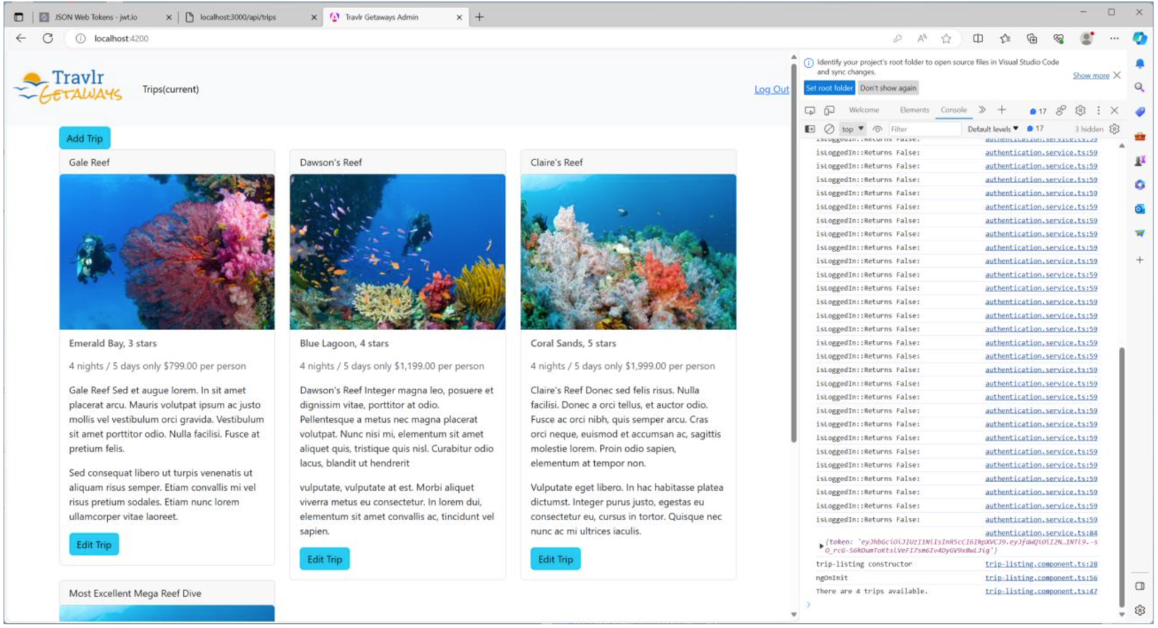

References
Coronel, C., & Morris, S. (2018). Database systems: Design, implementation, and management
(13th ed.). Cengage Learning.

